Chemical workplace assessment Link

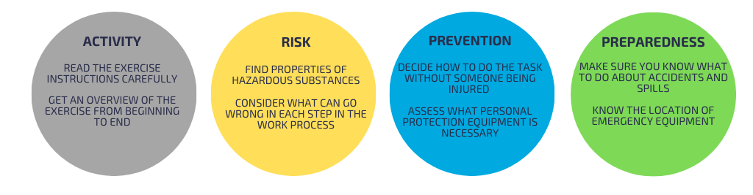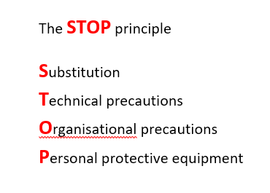
Activity:

Period/date:
Name(s):

Project Lab Technician:
Supervisor:

Approved: _____________________________________________

1. Reagents/products (conc.) included in the activity:
A:
B:
C:
Expand with D, E etc. if more.

2. Name and quantity of the substances/materials included in the individual reagents:
Compound | Total quantity ([g]/[mL]/[mol]) | Substance/material | Quantity [g/mL/mol] | Substitution (STOP) | CAS No./  P-number
A:
B:
C:

Expand if more.

3. Process description
Detailed description/diagram of the work process that includes substances, materials and equipment that can contribute to the risk.
Analysis/Process: (STOP)
4. Safety in preparing reagents
Find hazard labelling and waste group for the concentrated substances and materials used in preparing reagents.
Substance/product | Hazard pictogram & signal word | H-phrases | P-phrases | Waste group
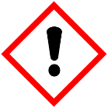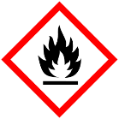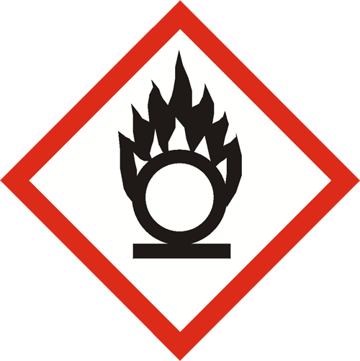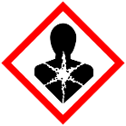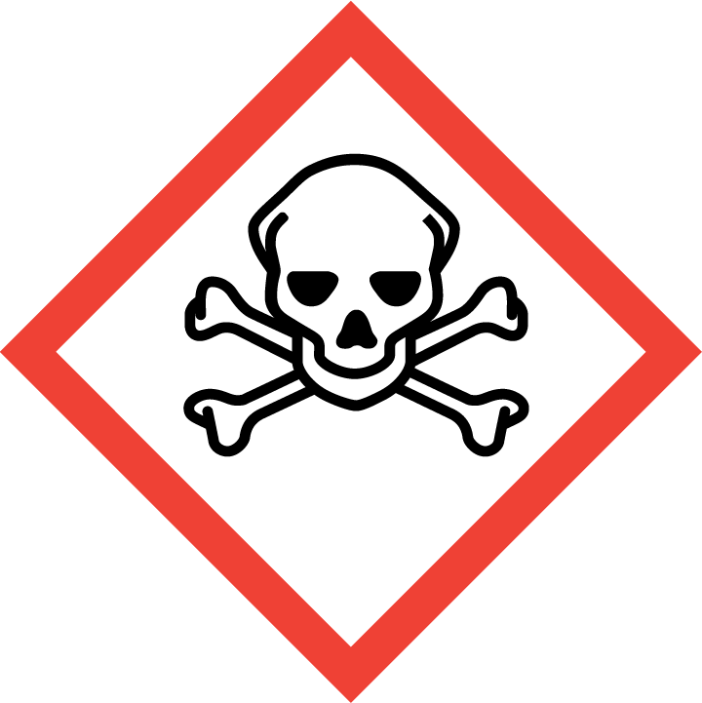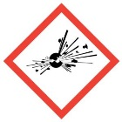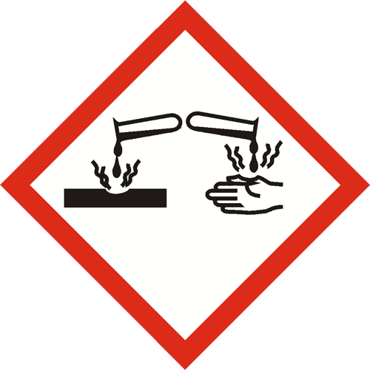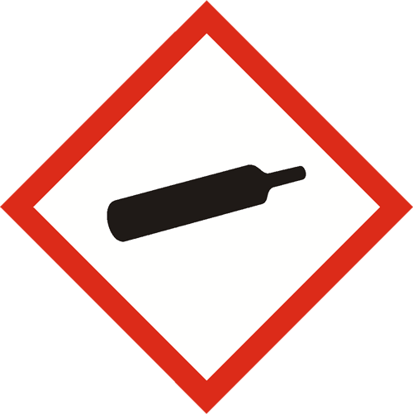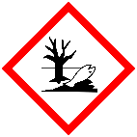
5. Prevention and preparedness when handling pure substances while preparing individual reagents/products.
Examine special precautions, personal protective equipment (STOP) and other preventive measures as well as emergency preparedness in case of accident/spillage/etc.
Compound/product | Prevention (Special precautions, personal protective equipment, etc.) | Preparedness
A:

B:

C:

Expand if more.

6. Safety in use of reagents
Calculate the hazard labelling for the reagents (CLP calculator, Kemibrug.dk ) and find waste groups (sorting key ), special conditions regarding storage are noted.
Compound/product | Hazard pictogram & signal word | H-phrases | P-phrases | Waste group | Storage
A:

B:

C:

Expand if more.

7. Prevention and preparedness when using the individual reagent/products.
Examine special precautions, personal protective equipment (STOP) and other preventive measures as well as emergency preparedness in case of accident/spillage/etc.
Compound/product | Prevention (Special precautions, personal protective equipment, etc.) | Preparedness
A:

B:

C:

Expand if more.

